Васильева ип-19-3

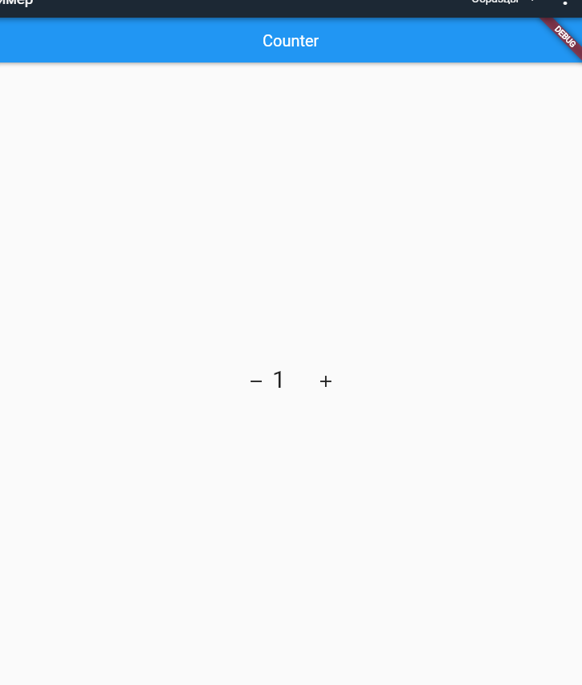

import 'package:flutter/material.dart';

void main() => runApp(MyApp());

class MyApp extends StatelessWidget {

@override

Widget build(BuildContext context) {

return MaterialApp(

home: MyHomePage(

title: 'Counter',

),

);

}

}

class MyHomePage extends StatefulWidget {

MyHomePage({Key? key, required this.title}) : super(key: key);

final String title;

@override

_MyHomePageState createState() => _MyHomePageState();

}

class _MyHomePageState extends State<MyHomePage> {

int _counter = 0;

void _incrementCounter() {

setState(() {

_counter++;

});

}

void _decrementCounter() {

setState(() {

_counter--;

});

}

@override

Widget build(BuildContext context) {

return Scaffold(

appBar: AppBar(

title: Text(widget.title),

centerTitle: true,

),

body: Center(

child: Container(

child: Column(

mainAxisAlignment: MainAxisAlignment.center,

children: <Widget>[

new Container(

child: Wrap(

children: <Widget>[

IconButton(

icon: Icon(Icons.remove),

onPressed: _decrementCounter,

),

Text(

'$_counter',

style:TextStyle(

fontSize: 30,

letterSpacing: 30)),

IconButton(

icon: Icon(Icons.add),

onPressed: _incrementCounter,

),

],

)

),

],

),

),

),

);

}

}